**Practical: 3**

**Aim: Enterprise Process Identification.**

opentaps offers a complete solution for your business, from your online store and sales teams to customer service, warehouse, inventory, shipping, manufacturing to accounting and reporting.  It also can link your retail stores with an integrated point of sales system.   Here are some of the most popular features in opentaps:

**eCommerce Online Store**

* Support unlimited stores, catalogs, categories, and products
* Cross-sells and upsells for products
* Support physical products, digital and downloadable products, variant products, configurable products, and customer gift cards
* Price rules for customer or group-specific pricing
* Online store promotion engine
* Integration with major payment gateway providers
* Fully integrated online and Point of Sales (POS) stores out-of-the-box
* Keyword search capability in all the applications using hibernate search

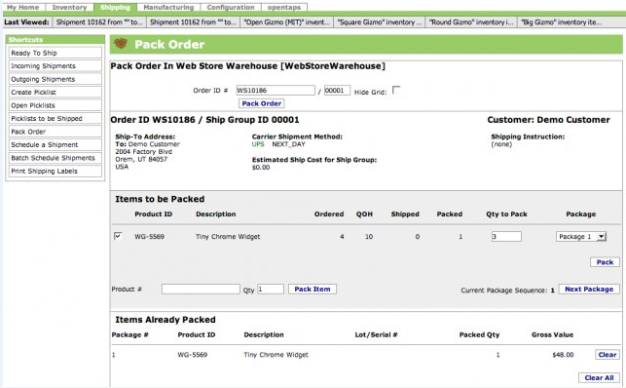

Online store

**CRM Features**

* Automate sales process from lead gathering to conversion
* Manage sales opportunities
* Create sales visibility with forecasts
* Share calendar and tasks with the entire team
* Share and manage documents
* Browser-based email with integration to email server
* Customer services and case management
* Quotes, order entry, and order prioritization
* Manage marketing campaigns, including outbound emails and call management
* Tracking code reporting and management
* Address lookup and correction via USPS
* Integration with Asterisk open source Voice over IP (VOIP) system
* Integration with **[GetResponse email marketing](http://www.getresponse.com/index/sichen)** with **[opentaps-GetResponse integration module](http://shop.opentaps.org/index.php/featured/getresponse-email-marketing-integration-module.html)**
* Support for Value Added Taxes (VAT) through [**VAT module**](http://shop.opentaps.org/index.php/featured/vat-module-by-integratingweb.html)

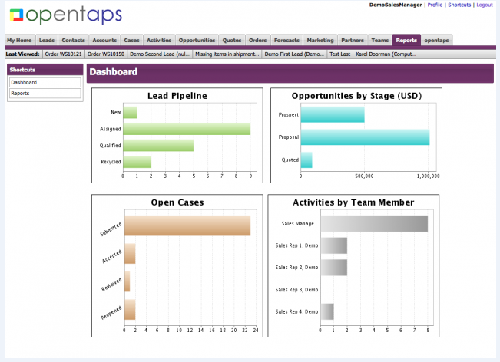

CRM module

**Warehouse and Manufacturing Features**

* Track non-serialized, serialized, and lot-based inventory
* Host third-party or "virtual" inventory
* Manage entire manufacturing process with Bill of Materials (BOM), production tasks, and work orders
* Fulfill orders efficiently with picking lists, web-based packing station, and shipment scheduling
* Integration with UPS, FedEx, DHL, and **[Endicia](http://www.endicia.com/default.cfm?referredby=a14b)**

**Financial Management and Accounting Features**

* Industry standard double entry general ledger
* Supports multiple organizations with unlimited hierarchy of accounts
* Manage accounts receivables (AR) and accounts payables (AP), including invoices, payments, statements, aging
* Produce financial and tax statements, including income statement, balance sheet, cash flow statement, trial balances, tax summary and detail reports
* Fully integrated with orders, inventory, purchasing, manufacturing out-of-the-box
* Scheduled transactions postings
* Recurring invoices
* Third party billing support
* Ability to segment financial results using "tags" for divisions, departments, product lines, activities, etc.
* Budgeting and encumbrance reporting
* Ordering and invoicing of services
* Support for Value Added Taxes (VAT) through [**VAT module**](http://shop.opentaps.org/index.php/featured/vat-module-by-integratingweb.html)
* Additional reconciliation reports and AR/AP funcationality through [**Enhanced Financials Module**](http://shop.opentaps.org/index.php/featured/enhanced-financials-module.html)

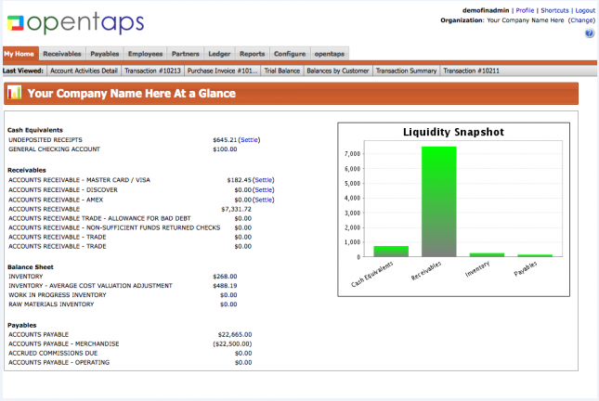

Finance module

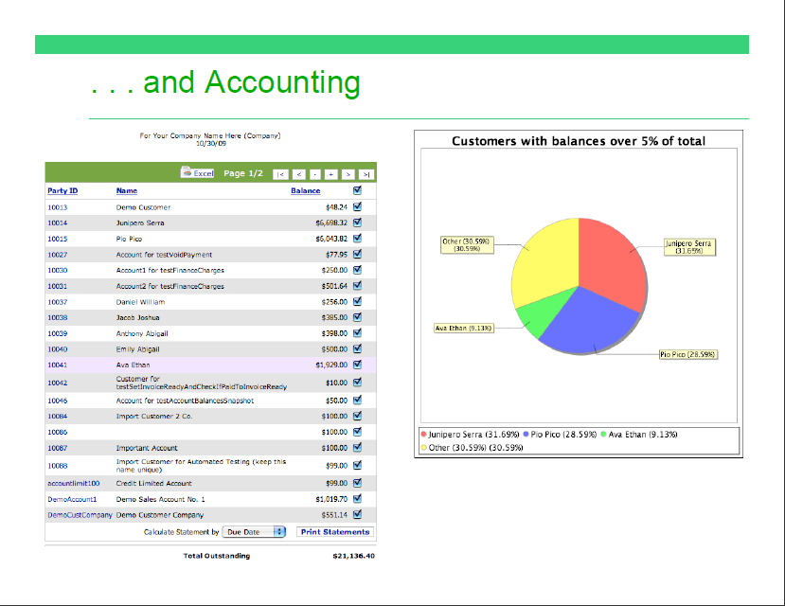

**Purchasing and Supply Chain Management**

* Manage Suppliers records, including contact information
* See real time inventory
* Automate production and purchasing calendar with Material Resources Planning (MRP)
* Use requirements to streamline purchasing work flow
* Support for Value Added Taxes (VAT) through [**VAT module**](http://shop.opentaps.org/index.php/featured/vat-module-by-integratingweb.html)

**Business Intelligence and Reporting**

* Support for data transformation using Pentaho open source business intelligence
* Graphical WYSIWYG report writer (iReport) and ad hoc reporting using Jasper Reports
* [**opentaps Analytics**](http://www.opentaps.org/docs/index.php/Opentaps_Analytics) allows in-depth look at customer and sales data

**Technical Highlights**

* Built on Java J2EE with a Service Oriented Architecture and Model-View-Controller framework
* Compatible with all major databases, including MySQL, PostgreSQL, Oracle, and SQL Server
* Support for XML RPC, SOAP, and SyncML integration protocols
* Incorporates the Apache Tomcat and Geronimo servers
* Supports Java 6
* Combines Apache OFBiz framework with object-oriented domain driven architecture
* Ajax widgets with the Google Web Toolkit
* LDAP and Kerberos Single Sign On (SSO) support
* SSL support, OWASP, and encryption of sensitive data for security

**Additional modules**

* Project management
* Human resources
* Fixed asset management
* Outlook and mobile phone integration with Funambol
* Integration with eBay, Google base, Google check out
* Content management
* Point Of Sales
* Magento ecommerce integration
* [**Enhanced Financials module**](http://shop.opentaps.org/index.php/featured/enhanced-financials-module.html)
* [**VAT module**](http://shop.opentaps.org/index.php/featured/vat-module-by-integratingweb.html)
* [**GetResponse email marketing integration**](http://shop.opentaps.org/index.php/featured/getresponse-email-marketing-integration-module.html)